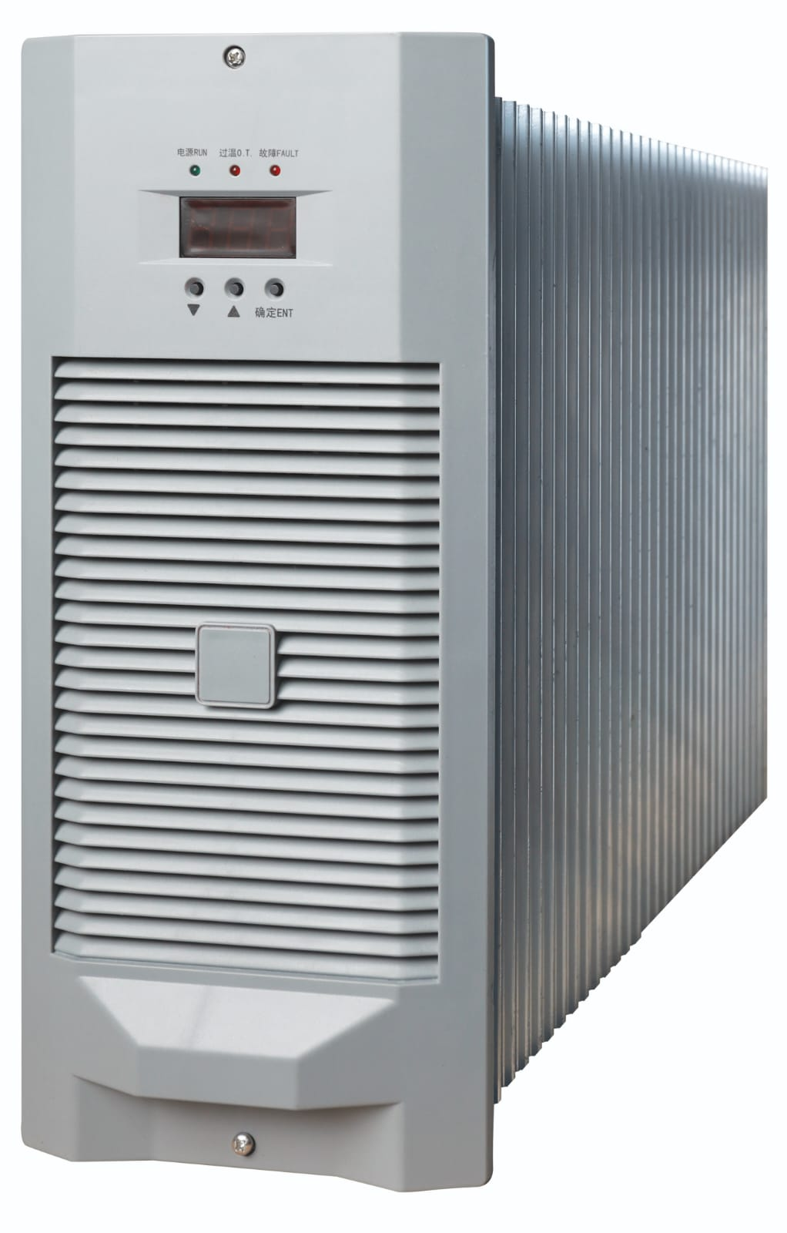   | An ISO 9001:2015 Company  Power up with  Poweregy

SMPS Based

Rectifier Module
www.poweregy.in


Discover a new era of power electronics solutions with Poweregy!
We are dedicated to bringing you innovative and reliable power electronics solutions that cater to your diverse energy needs. Our extensive range of cutting-edge products, including utility rectifiers, portable battery chargers and DC-DC converters is meticulously crafted to elevate your power experience.
Our team of skilled engineers and experts bring years of experience to the table, offering tailored solutions to meet your unique requirements.

Our utility rectifiers are engineered to deliver consistent and reliable charging for various battery types with advanced technology and smart features, these chargers are designed to maximize battery life and ensure safety.

 |  | 
In Our Bucket  - 220V  - 110V  - 48V  - 24V  - Controllers  - BMS  - IMU | Major Highlights  - Single or Three phase input  - Natural or force Cooled  - PFC or APFC  - Unity Power Factor  - Hot Swappable  - Designed in 50 deg. C.  - Higher Efficiency  - Perfect current sharing  - Temperature Compensation

220V Rectifier
Model  Items |  |  | HA220D20Z  -220A
Output current（A） |  |  | 20
Power（KW） |  |  | 6.0
Input voltage  range（VAC） | Min |  | 187
Input voltage  range（VAC） | Typical |  | 220
Input voltage  range（VAC） | Max |  | 253
Output  Adjustable  Voltage  rang（VDC） | Min |  | 190
Output  Adjustable  Voltage  rang（VDC） | Typical |  | 220
Output  Adjustable  Voltage  rang（VDC） | Max |  | 300
voltage stabilization |  |  | ±0.5%
POWER FACTOR |  |  | 0.99(WITH APFC)
THD(CURRENT) |  |  | ≤5%
Charger efficiency（efficiency） |  |  | ≥94%
Audible Noise max（dB） |  |  | 50
Storage temperature（℃） |  | Min | -40
 |  | Typical | 25
 |  | Max | 60
Working  Conditions  temperature（℃） |  | Min | -10
 |  | Typical | 25
 |  | Max | 50
uneven current in parallel operation |  |  | <±3%
Start delay (s) |  |  | 3S-8S
Ripple factor |  |  | ≤0.5%
Load grade |  |  | Continuous working with Grade I(100%) rating output current
Automatic current limiting technology |  |  | The output current cannot increase infinitely. When output current value is over than limited current value, there will be limited constant current output. The maximum output current value of each module is limited to the rated output.
Output overvoltage protection function |  |  | After output overvoltage occurs(320±5VDC), the module locks up automatically
output short circuit protection |  |  | When the output current get short circuit, the module will protect itself from broken. After the faults get removed, it will restart working automatically.
Note：The constant Voltage Stabilization Tolerance does not contain the built-in isolating diode's influence。

110V Rectifier
Model  Items |  |  | HA110D20Z  -220A
Output current（A） |  |  | 20
Power（KW） |  |  | 3.0
Input voltage  range（VAC） | Min |  | 187
Input voltage  range（VAC） | Typical |  | 220
Input voltage  range（VAC） | Max |  | 253
Output  Adjustable  Voltage  rang（VDC） | Min |  | 88
Output  Adjustable  Voltage  rang（VDC） | Typical |  | 125
Output  Adjustable  Voltage  rang（VDC） | Max |  | 150
voltage stabilization |  |  | ±0.5%
POWER FACTOR |  |  | 0.99(WITH APFC) and THD < 5%
Charger efficiency（efficiency） |  |  | ≥93%
Audible Noise max（dB） |  |  | 50
Storage temperature（℃） |  | Min | -40
 |  | Typical | 25
 |  | Max | 60
Working  Conditions  temperature（℃） |  | Min | -10
 |  | Typical | 25
 |  | Max | 50
uneven current in parallel operation |  |  | <±3%
Start delay (s) |  |  | 3S-8S
Ripple factor |  |  | ≤0.5%
Load grade |  |  | Continuous working with Grade I(100%) rating output current
Automatic current limiting technology |  |  | The output current cannot increase infinitely. When output current value is over than limited current value, there will be limited constant current output. The maximum output current value of each module is limited to the rated output.
Output overvoltage protection function |  |  | After output overvoltage occurs(320±5VDC), the module locks up automatically
output short circuit protection |  |  | When the output current get short circuit, the module will protect itself from broken. After the faults get removed, it will restart working automatically.
Note：The constant Voltage Stabilization Tolerance does not contain the built-in isolating diode's influence。

48V Rectifier
module  project |  |  | HA48D60-220F
rated output current(A) |  |  | 60
power（KW） |  |  | 3
weight(kg) |  |  | 10.5
cooling method |  |  | fan cooling
heat sink temperature rise |  |  | ≤20℃
rang of input AC（VAC） |  | min | 190
 |  | Typical value | 220
 |  | max | 280
rang of the output voltage（VDC） |  | min | 42
 |  | Typical value | 48
 |  | max | 58
stable voltage accuracy: |  |  | ±0.5%
stable current accuracy: |  |  | ±1%
Power factor |  |  | 0.99
thd |  |  | ≥5%
Efficiency |  |  | ≥92%
noise（dB） |  |  | 50
Storage temperature（℃） | min |  | -40
Storage temperature（℃） | Typical value |  | 25
Storage temperature（℃） | max |  | 70
working temperature（℃） | min |  | -10
working temperature（℃） | Typical value |  | 25
working temperature（℃） | max |  | 55
And machine uneven fluidity |  |  | ≤±3%
time delay of start-up（s） |  |  | 3~8
Wave factor |  |  | ≤0.2%
Load |  |  | 100% rated output current
stepless current limiting techonoly |  |  | The output current cannot increase infinitely. The maximum value of the output current of each module is limited to the rated output current
Output overvoltage protection function |  |  | After output overvoltage occurs(61±3VDC), the module locks up automatically
output short circuit protection |  |  | When output short circuit, the module draws the output voltage to 0 immediately
Note：The constant voltage precision does not contain the built-in isolating diode's influence。

24V Rectifier
Model  Items |  |  | HA24D100Z  -220A
Output current（A） |  |  | 100
Power（KW） |  |  | 3.0
Input voltage  range（VAC） | Min |  | 187
Input voltage  range（VAC） | Typical |  | 220
Input voltage  range（VAC） | Max |  | 253
Output  Adjustable  Voltage  rang（VDC） | Min |  | 21
Output  Adjustable  Voltage  rang（VDC） | Typical |  | 24
Output  Adjustable  Voltage  rang（VDC） | Max |  | 29
voltage stabilization |  |  | ±0.5%
POWER FACTOR |  |  | 0.99(WITH APFC)
THD(CURRENT) |  |  | ≤5%
Charger efficiency（efficiency） |  |  | ≥90%
Audible Noise max（dB） |  |  | 50
Storage temperature（℃） |  | Min | -40
 |  | Typical | 25
 |  | Max | 60
Working  Conditions  temperature（℃） |  | Min | -10
 |  | Typical | 25
 |  | Max | 50
uneven current in parallel operation |  |  | <±3%
Start delay (s) |  |  | 3S-8S
Ripple factor |  |  | ≤0.5%
Load grade |  |  | Continuous working with Grade I(100%) rating output current
Automatic current limiting technology |  |  | The output current cannot increase infinitely. When output current value is over than limited current value, there will be limited constant current output. The maximum output current value of each module is limited to the rated output.
Output overvoltage protection function |  |  | After output overvoltage occurs(29±2VDC), the module locks up automatically
output short circuit protection |  |  | When the output current get short circuit, the module will protect itself from broken. After the faults get removed, it will restart working automatically.
Note：The constant Voltage Stabilization Tolerance does not contain the built-in isolating diode's influence。

BMU Unit

Wiring schematic
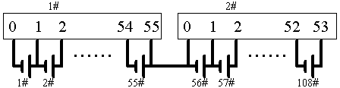

Identify | Description
0 | NO.1 cell negative.( battery’s negative ) | Range：0~4V
1 | NO.1 cell positive。（ NO.2 cell negative ） | Range：0~4V
2 | NO.2 cell positive。（ NO.3 cell negative ） | Range：0~4V
… | … | Range：0~4V
55 | NO.55 cell positive battery’s positive） | Range：0~4V
Temp1 | Temperature sensor 1 interface | Range：-10℃~+100℃
Temp2 | Temperature sensor 2 interface | Range：-10℃~+100℃
Address | Unit address，ON position is 0，inverse position is 1
RS485 | RS485 interface。
Power | Power supply range 90-300VDC。

IMU Unit
Overview
IMU-64 unit measures 2 bus insulation、64 branch insulation, transfers it to host by RS485.
Measures 2 bus insulation。
Measures 64 branch insulation。
Measure cycle：≤60S

Identify | Description
1 | NO.1 branch sensor output
…… | ……
64 | NO.64 branch sensor output
 | +12V | branch sensor power supply +12V
 | GND | branch sensor power supply GND
 | -12V | branch sensor power supply -12V
K1 | Relay output, NO Capacity AC250V/5A，DC30V/5A
KM2 | Control bus 2 positive
HM2 | Drive bus 2 positive
-M2 | Bus 2 negative
KM1 | Control bus 1 positive
HM1 | Drive bus 1 positive
-M1 | Bus 1 negative
 | Earth
COM | parallel operation interface
Addr | Unit address，ON position is 0，inverse position is 1
RS485 | RS485 interface
Power | Power supply，range 90~300VDC

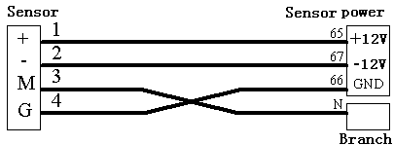

Protection
Output overvoltage protection
To prevent the accident caused by output overvoltage, there is overvoltage protection circuit in the module. When output overvoltage occurs, the module locks up automatically, the relative module fault indication light is on, the faulty module quits work automatically and doesn’t affect the normal operation of the entire system.

Output current limiting protect
The output current cannot increase infinitely. The maximum value of the output current of each module is limited to the rated output current 105%, in this range, the output current value of the module is continuously adjustable. If the load output of the module, the module will play down the output voltage

Output short-circuit protection
When short circuit happened, the output voltage of module goes to 0 immediately, limit the short circuit current below 15% limit current point to protect the module. The module will not be damaged under short circuit state for a long time, and can go back to work automatically after debugging.

Module parallel protection
There is parallel protection circuit in each module to ensure that when the fault module quits the system, the normal work of other modules and the system won’t be effect.

Over-temperature protection
Over-temperature protection is mainly for protecting large power converters, under normal operating circumstance, the module design leaves enough margin, under special circumstance, when the module detects that the temperature of the radiator is over 90℃, it will shut down automatically to protect itself. When the temperature of radiator get down, the module will restart work automatically.

Output over-current protection
Because of the limit of the module output power, the output current cannot increase infinitely. In the range, the output current value of the module is continuously adjustable. If overloaded, the module can reduce output voltage automatically to make it not surplus the rated output limit point in order to protect the power components. The over current protection can be resumed automatically.

Mechanical

Sl. No. | Rectifier Module
1. | 220V 10A
2. | 220V 20A
3. | 110V 20A
4. | 48V 50A
5. | 48V 25A
6. | 24V 50A
7. | 24V 100A
8. | 24V 200A

Mechanical Representation of a Rectifier Module

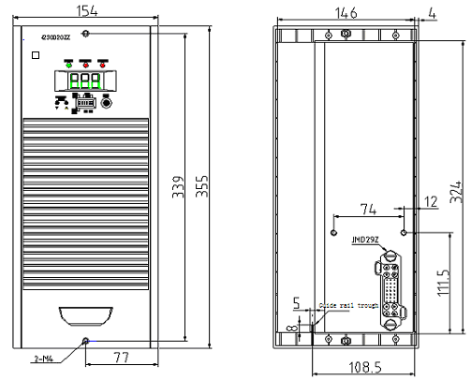

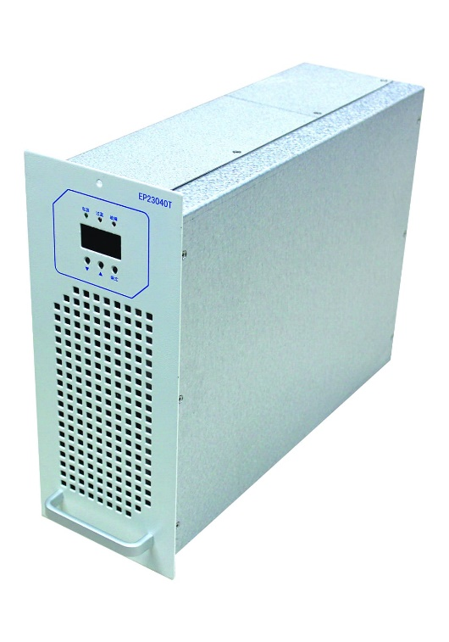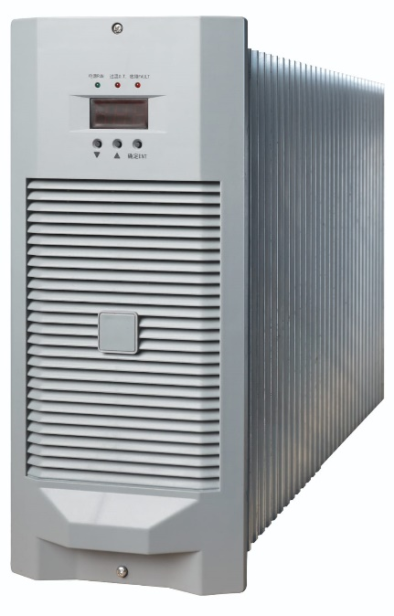

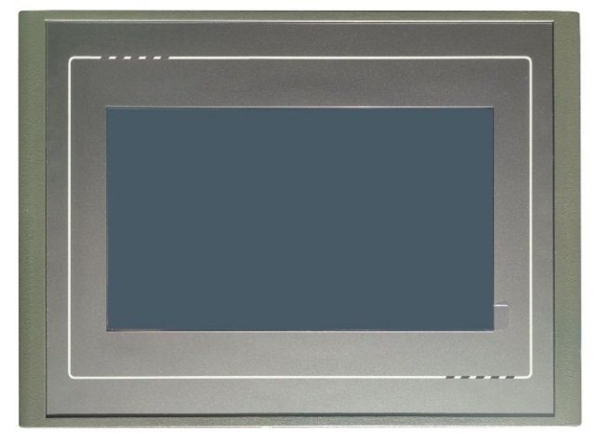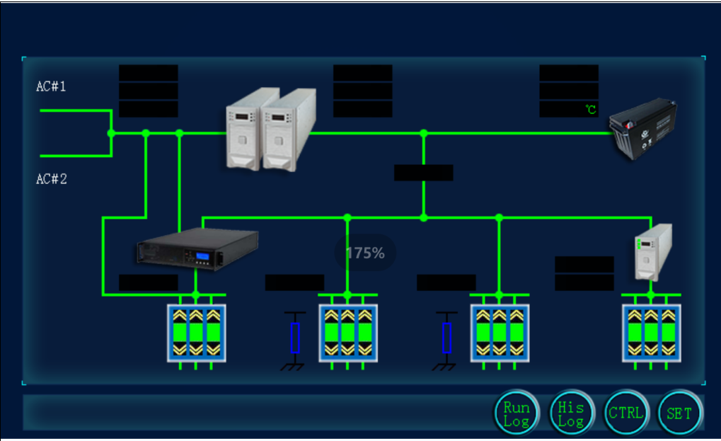

Poweregy
(Your Gateway to Advanced Power Electronics Solutions)

Address: 201, Sabarna Para road,
P.O.: Barisha , Kolkata: 700 041, West Bengal, India
M: +91 84202 52305
Email: sales.poweregy@gmail.com/sales@poweregy.in

